* **@RestController**

Return API

Combines @Controller and @ResponseBody.

VD:

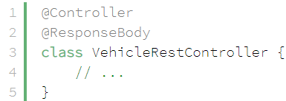 tương đương 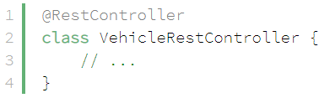

* **@Controller**

Return ModelAndView (giống JSP & Servlet)

* **Reference**